West Gaines School
Lawrenceburg, TN

Historic Overview and
Preliminary Conditions Assessment

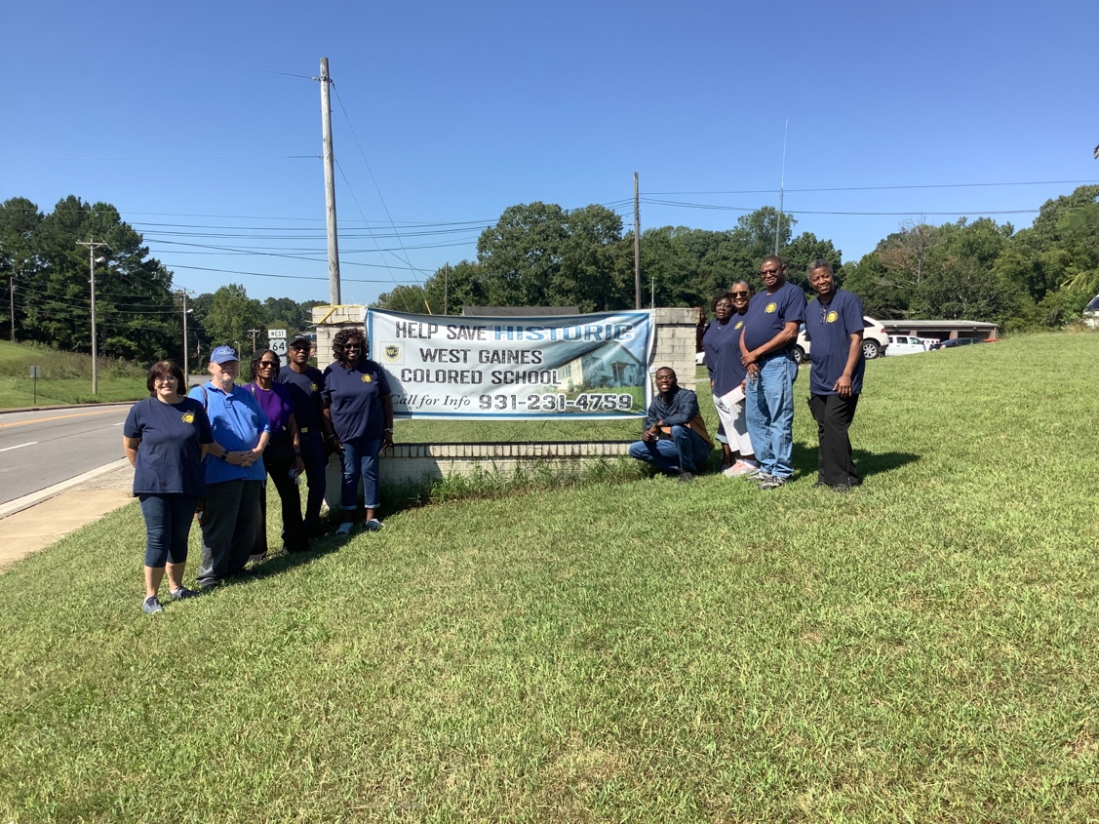
A Public Service Project
December 2022



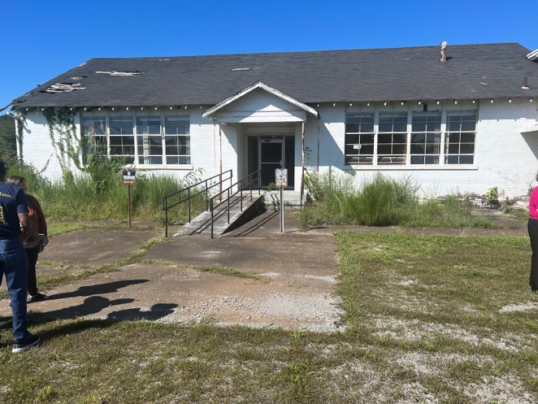

Prepared for:
West Gaines Community Center
410 West Gaines Street
Lawrenceburg, TN 38464

Prepared by:
Paul Springer Jr.
Dr. Carroll Van West, Director

Introduction
On September 13, 2022, the MTSU Center for Historic Preservation, consisting of Dr. Carroll Van West, CHP Fieldwork Coordinator Savannah Grandey-Knies, and CHP Graduate Research Assistants Taylor Means, and Paul Springer Jr., met with West Gaines Community Center leaders, school alumni, and interested citizens at St. John's United Methodist Church in Lawrenceburg, Tennessee. The community wished to discuss possible support for the eventual preservation and restoration of the historic West Gaines school into a community center.
After the integration of schools in 1964, the Board of Education used the West Gaines School for a maintenance area and as offices/storage for years. By 2008, the county's Human Services Department used the location. Once the Human Services department left, the building was uninhabited.
In 2019, the West Gaines Community Center was formed to deter the demolition of the building. Headed by committee president James Wallace, and former alumni they have garnered support for the school’s preservation. The school remains significant to the community because it was the only school black children could attend during Jim Crow. More importantly, the black community in Lawrenceburg considers it the last public landmark of their past. At the September meeting, the group asked the MTSU Center for Historic Preservation to, first, develop a historic overview of the property and, second, provide some basic assessment of the school's preservation needs.

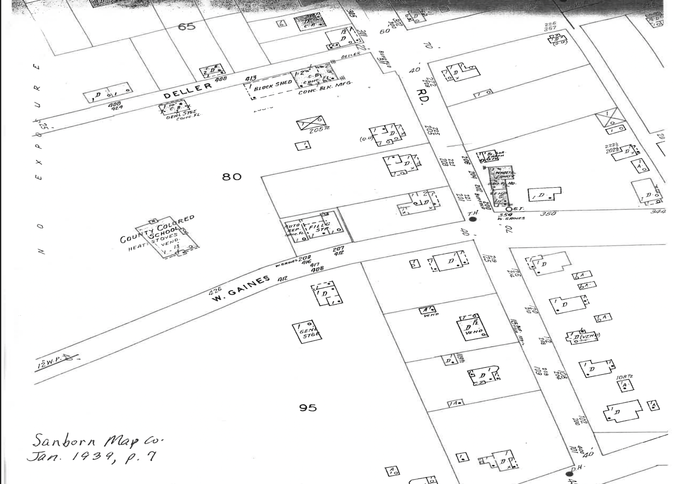
Sanborn map of Lawrenceburg, 1939
‘
Historical Context
The African American history of education in Lawrence County and its county seat Lawrenceburg remains to be written. We know from state records that 5 schools for Black children existed in 1875 and that number grew into the double digits within a segregated school system by the 20th century. The Black population in Lawrenceburg has never been large--about 2 percent in 1900 and most of that participating as tenant farmers in the local agricultural labor force. Not uncommon in the post-Reconstruction South, both Black adults and children participated in the labor force because families needed the income. Over 40 percent of black women (10 years old and older) participated in the labor force compared to only 16 percent of white women in 1900. Twenty-six percent of married black women were in the labor force compared to only three percent of married white women.
In Lawrenceburg, the black population was so small that they were relegated to the west on town, along West Gaines Street and Deller Street. The oldest landmark was St. John’s Methodist Church on West Gaines Street. Behind the school was a two-story frame building that served as Lawrenceburg's only school for African American students. The school held students from kindergarten to 8th grade and operated from c. 1875 to the early 1930s. Overcrowding had been a problem since the end of World War I as the county experienced a short-term boom in its agricultural production, especially cotton, and in industrial growth from a shirt factory. Teachers at the Lawrenceburg school during the 1920s were Mattie Caruthers, Lena Rhodes, Jacob Gay, and D.O Burrows. In addition to a school and church as public landmarks, there was a separate cemetery for African Americans, Symington cemetery, north of town.
During the economic boom in Lawrence County, a pivotal leader in the development of Lawrenceburg was James H. Stribling. Stribling was a small-town civic capitalist who invested in institutions that would both best serve his business interests and help the town grow. Founder of the First National Bank in Lawrenceburg, he became a community leader for public education. In 1928, the Lawrence County Board of Education appointed a committee to investigate building a new school for African Americans. The committee consisted of J.H Stribling, Joe Sims, and a Mr. Benson. The committee agreed that there was a need for a new school. By 1929, the committee had selected teachers, received funds from the Rosenwald fund ($500) and Black citizens raised $200 on their own. Also, in 1929, there were discussions of where the school should be located. Land owned by J.H Stribling, west of town, was considered as a potential destination. Stribling’s property was a 3-acre lot in District 8 of Lawrenceburg, and it was adjoined to the James T. Dunn Estate.
The tentative plans were for a 3-room brick building and for it to be supported by funding from the Julius Rosenwald Foundation. By spring of 1931, the committee had decided to proceed with construction of the building, and begin to make decisions on the faculty. The White community, now in the midst of the depression, did not support the location of the Black School on West Gaines Street (also the route of U.S. Highway 64). On April 14, 1931, a coalition of white citizens led by H.D Derrick filed an injunction to keep the school from being built. Derrick argued that the building would depreciate the property values, and disrupt the peace of the white neighborhoods. In the injunction, Derrick stated,
Said bill was filed for a common purpose and was antagonistic to the erection and construction of a negro school building upon said three acre tract assigning reason therefor that it was depreciative of property values in this immediate section and against the peace , tranquility and general welfare of Parties Complainant and repugnant to all white inhabitants and property owners within the immediate Section, and further alleging that it was an encouragement to the upbuilding of a negro settlement in the immediate environs of said proposed negro school building.
The White citizens also felt that a West Gaines Street location of the Black school would infringe on their white-only neighborhood and they did not want a new Black school located on the town's major east-west highway. H.D Derrick and his supporters took their case to the Tennessee Supreme Court but received an unfavorable decision in 1932. Although the citizens lost in the Supreme Court, this legal struggle contributed to the loss of Rosenwald funding first secured in 1929 since the Foundation ended the rural school building program in 1932.
From 1932 to 1937, the Lawrence County Board of Education developed plans for three new schools, one being a new West Gaines site. By the fall of 1937, with funding from New Deal agencies, the new school had been built at the intersection of West Gaines Street and Buffalo Road. Reflecting a general Rosenwald school design, the new building was heated with 65 single desks, 6 tables and 40 chairs.
In 1938, Joe A. Thomas and Willie Mae Parker were announced as principal and assistant principal of the new building. The Junior High School was located inside the same building as the elementary school. Thomas was a well-respected educator, elected by his peers as First Vice President of the Tennessee Negro Education Association in 1939. By the following year, he was president of the association. In 1941, he spoke at the commencement of the McNairy County Rosenwald School. By 1943, Thomas was the principal of the segregated black School for the Blind in Nashville.
For students who exceeded the 8th grade, they were forced travel via bus to Mt. Pleasant in Maury County, the only high school Black students were allowed to attend in the area. Black community members recall the inconvenience segregated schooling provided them. Shirley Dennis recalls black children having to be dropped off at the West Gaines location and then be transported to Mt. Pleasant, more than 20 miles away.
In c. 1950, the county board of education took state funding to add a gymnasium and additional classrooms to the school's north end. It remained a 1-8 grade school; high school students continued to attend the Mt. Pleasant school in Maury County.
For almost 30 years, the West Gaines school served as the only school for black children in Lawrenceburg. Desegregation of Lawrence County schools led to the closing of West Gaines School in 1964. Black children who were attending the school in its final year were transferred to various schools in the county.
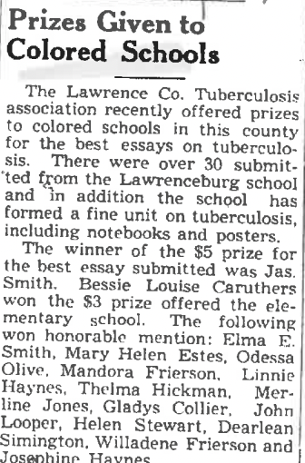

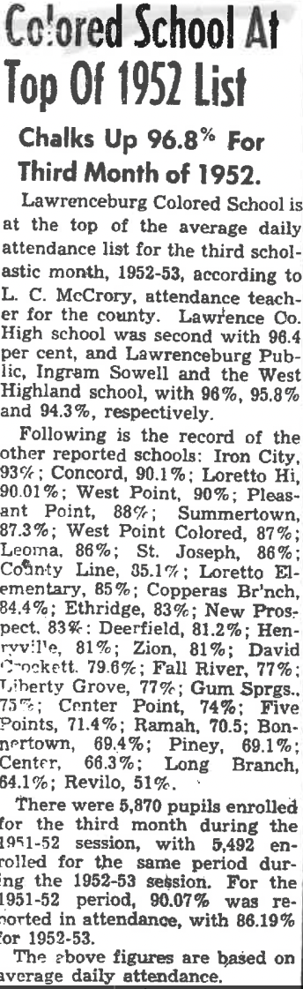
12 December 1952 (Democrat Union)
19 April 1940 (Democrat Union)

Preliminary Conditions Assessment
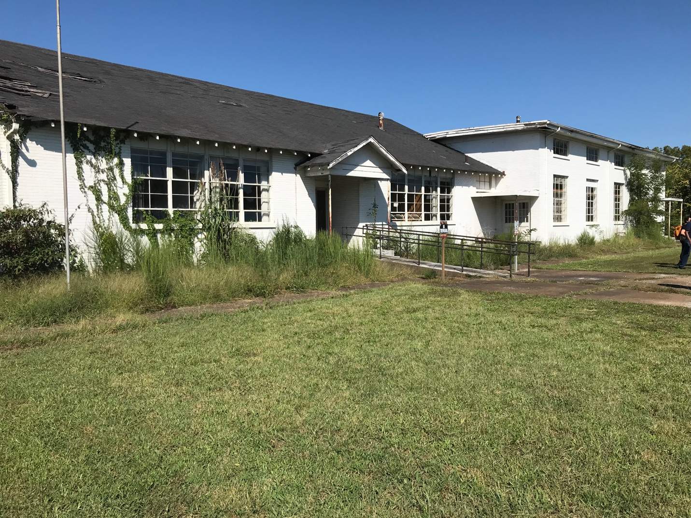
East Facade and primary entrances

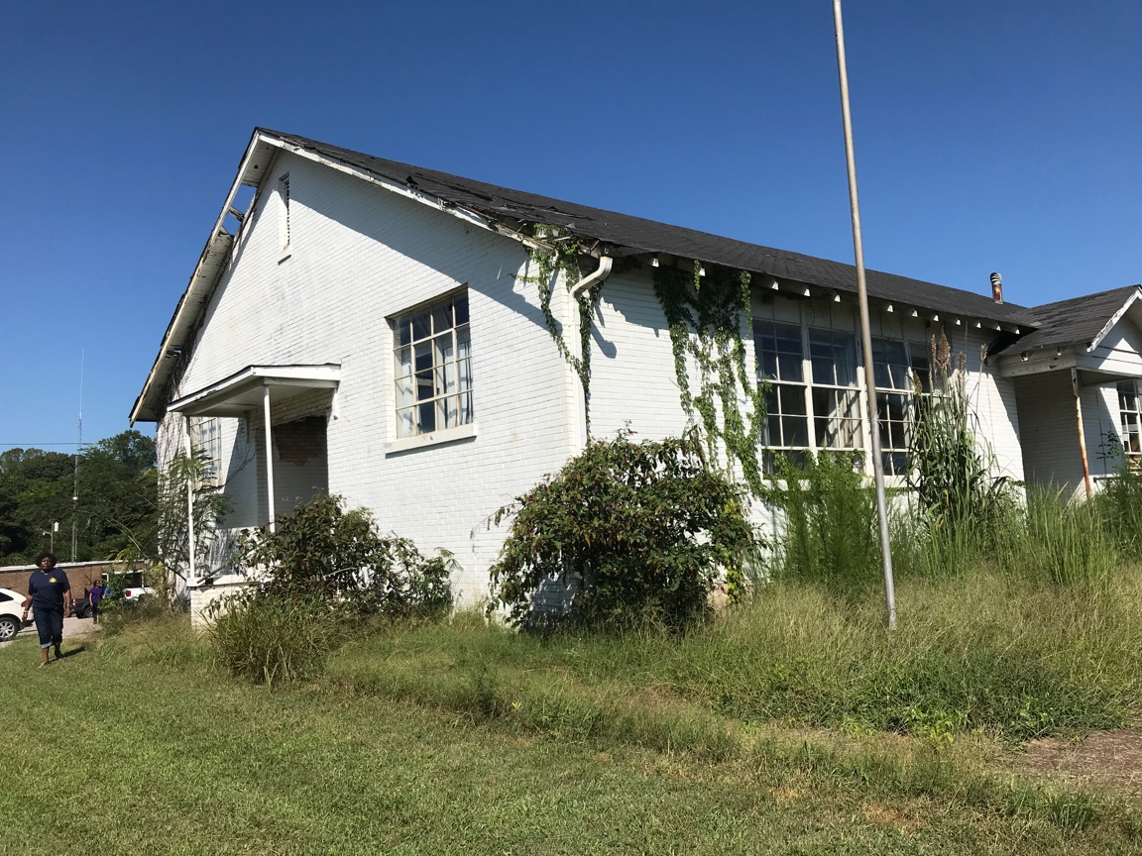
South entrance, facing U.S. 64, of original 1937-38 building. Note room damage.

Due to a lack of maintenance over the last ten years, and especially damage to the roof that has allowed an excessive amount of water into the building, the condition of the school is poor, but also well within the possibility of a full restoration. Weeds, and excessive plant growth are present on the sides of the walls, all of which retain moisture near the foundation.
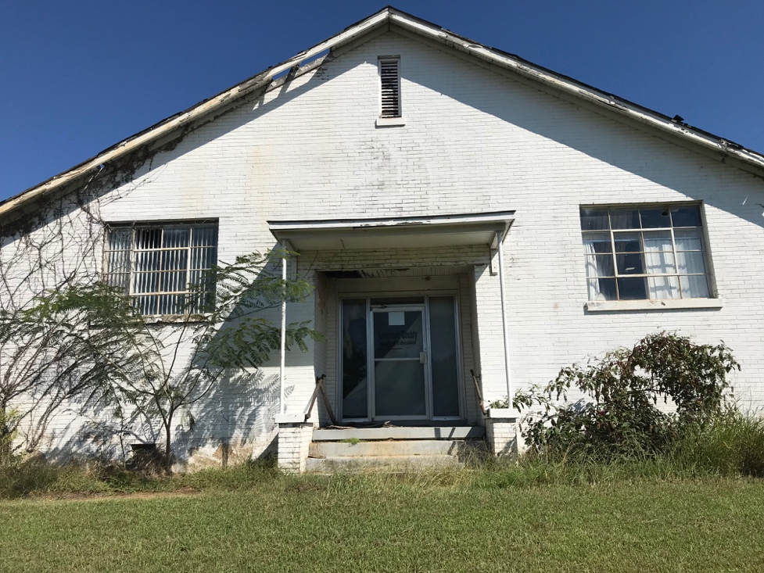
South entrance. Note intact windows, roof damage, and excess foliage along the walls.
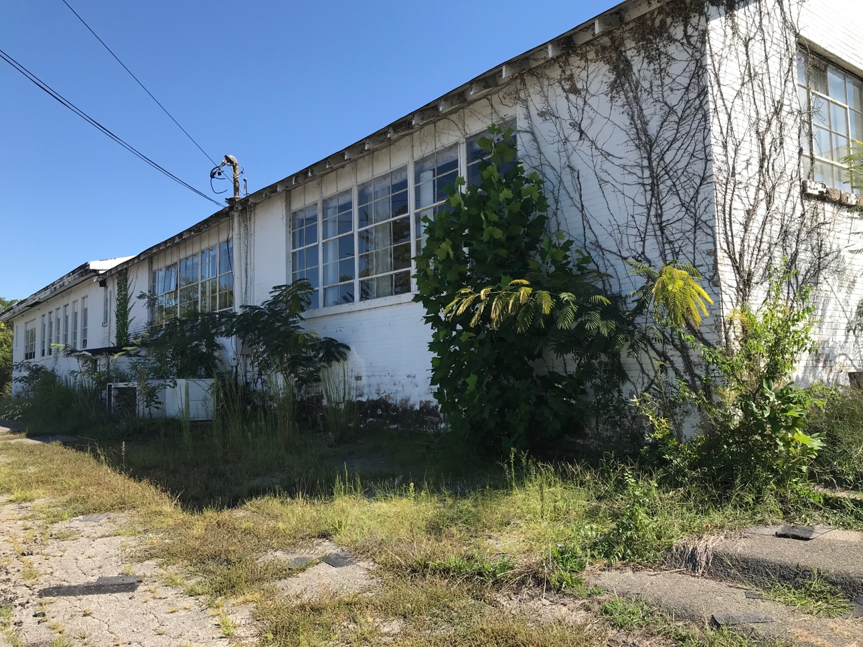
West elevation, emphasizing 1937-1938 section. Note that rafters and windows are intact. also note problem with foliage and moss/weeds around A/C unit.

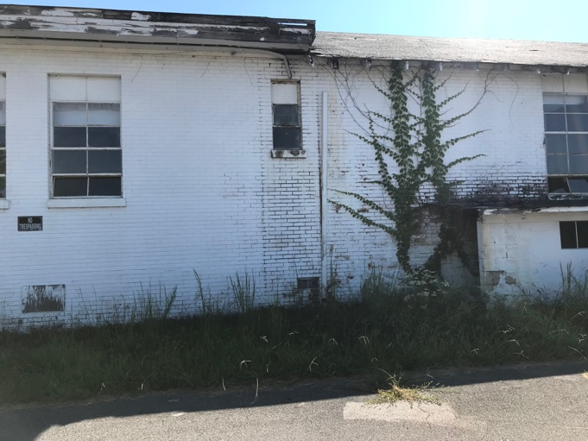
Hyphen that joined the two buildings c. 1952, and overgrown entrance into basement where a cafeteria was installed c. 1952
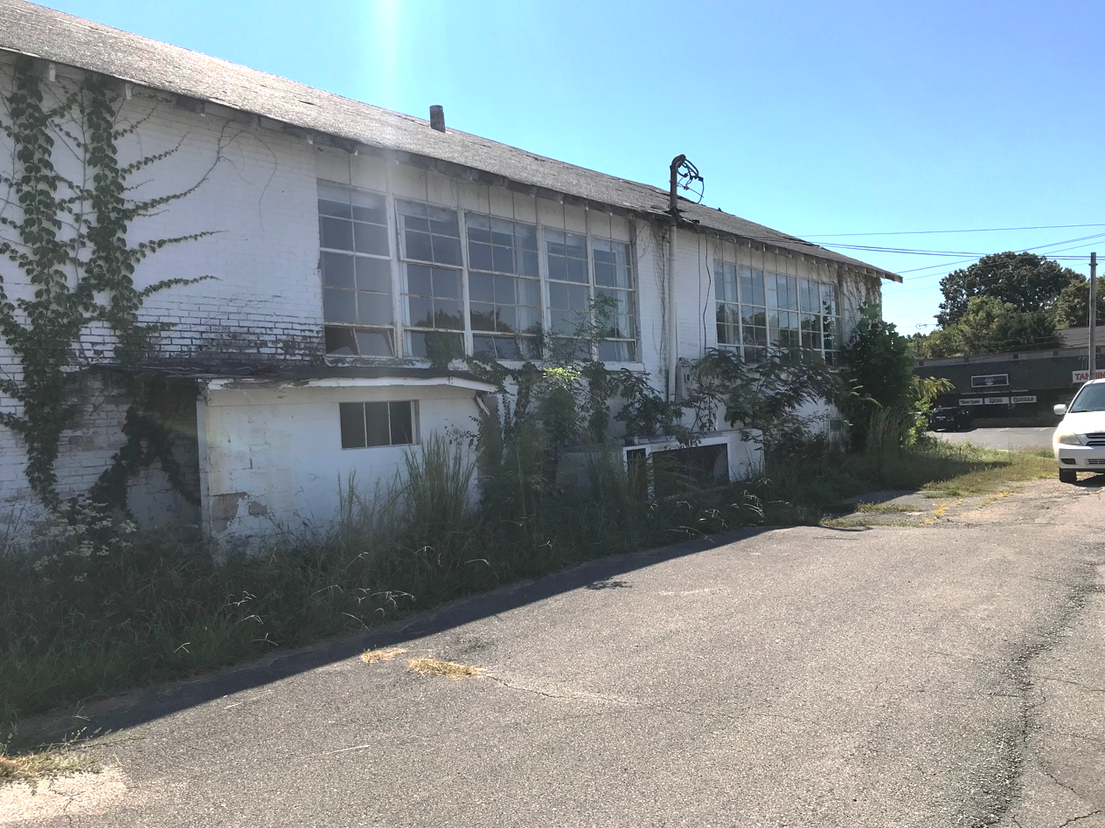
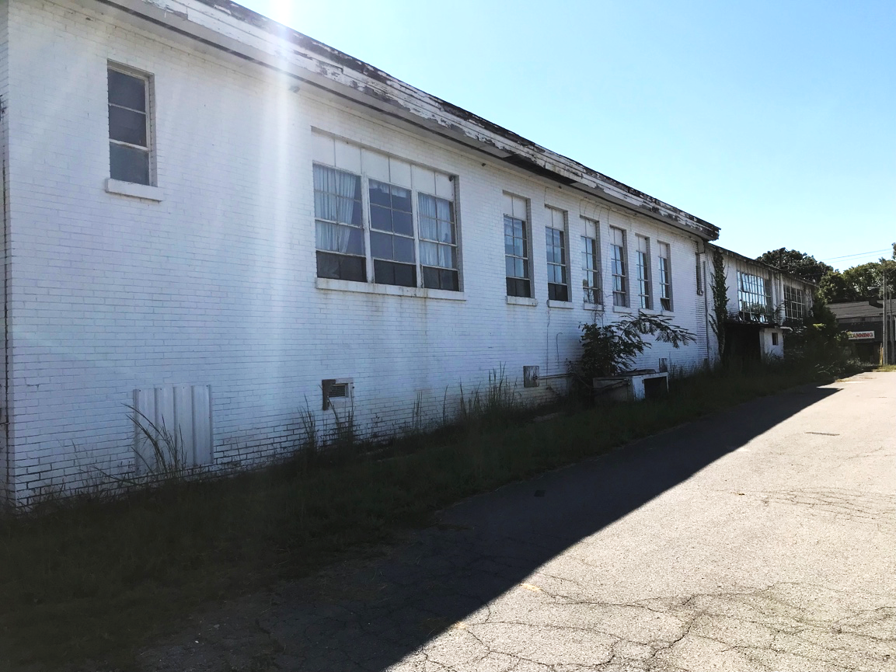
West elevation, emphasizing c. 1952 classroom additions

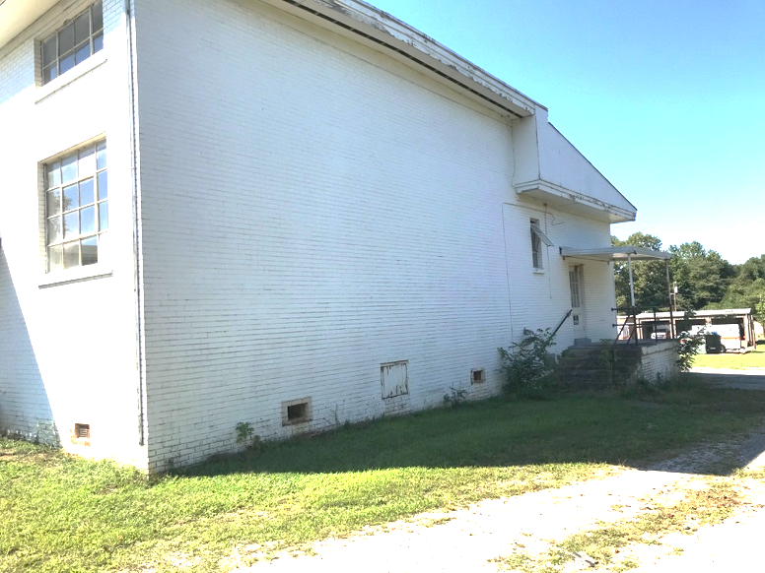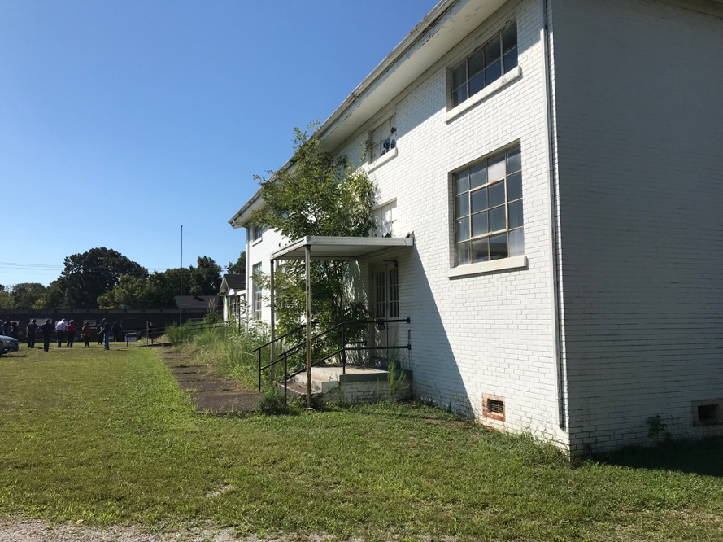
North elevation, with north entrance into the gymnasium and east entrance into the gymnasium

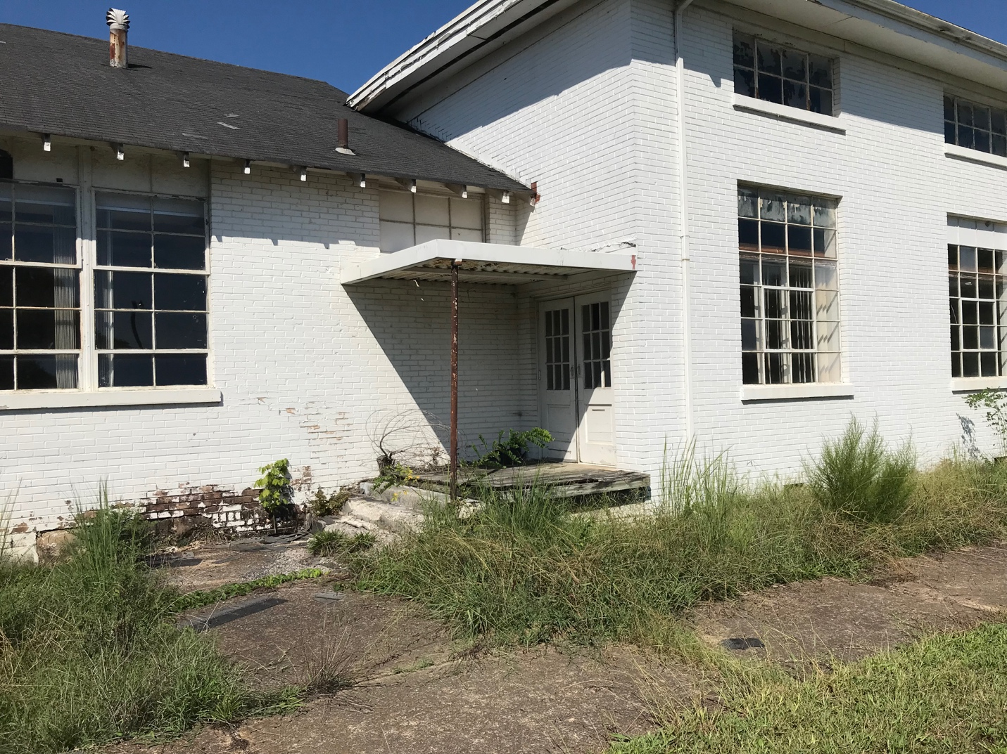
Primary entrance into the gymnasium, note original double doors and extant windows. Concrete steps have deteriorated.

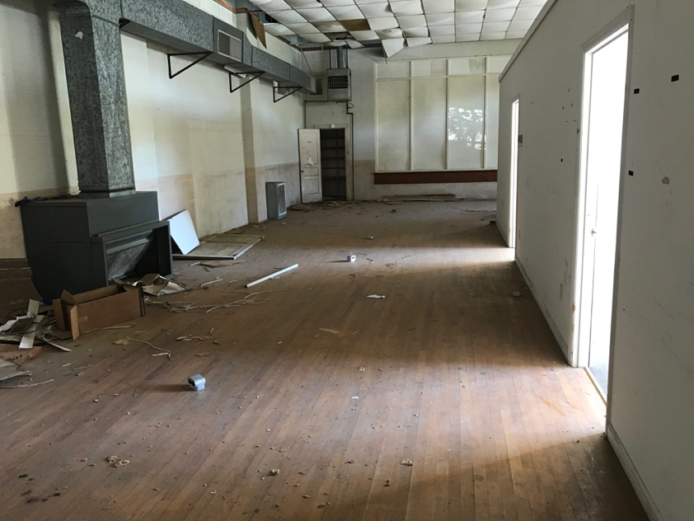
Majority of original gym floor is extant. Note the intrusion of a central A/C system and the partitions on the right that created two offices within the gym space. The partitions could removed and the gym space restored.

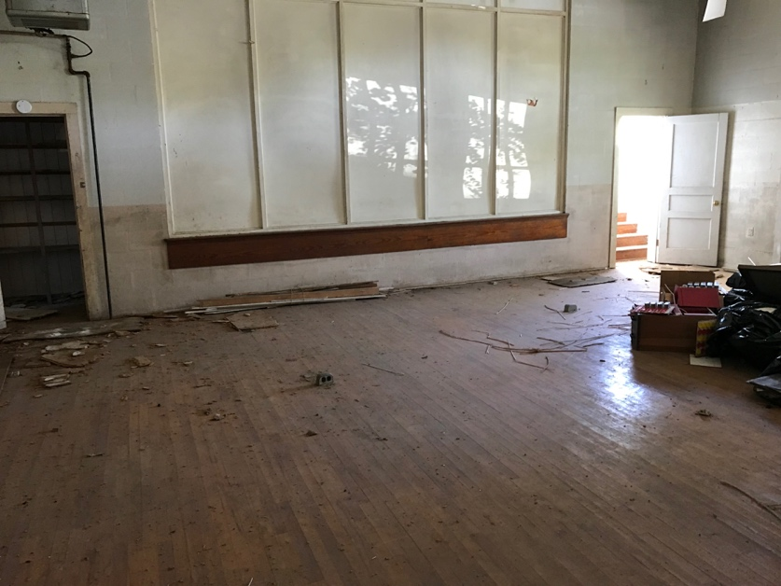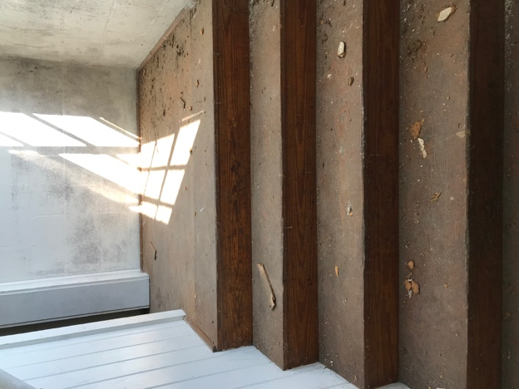

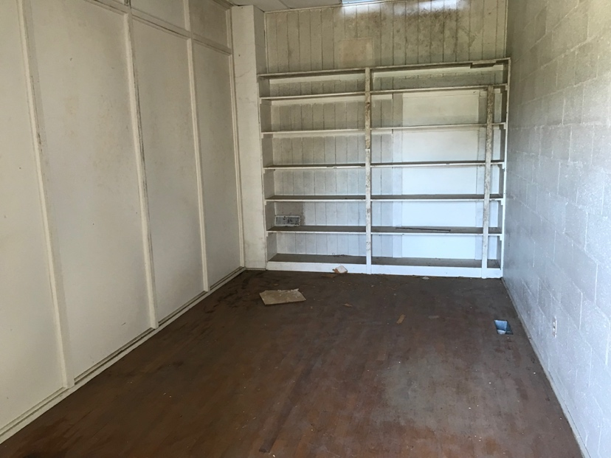
The stage was filled c. 2008 with a removable partition; original steps are extant. The installation of the shelves at one end of the stage probably came in 2008 and can be easily removed.

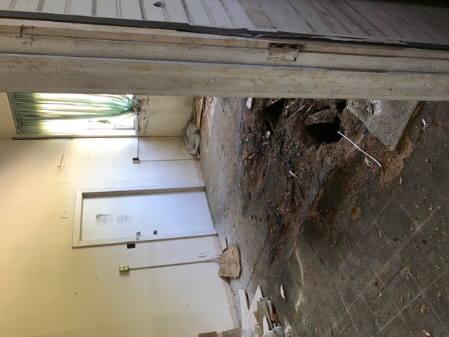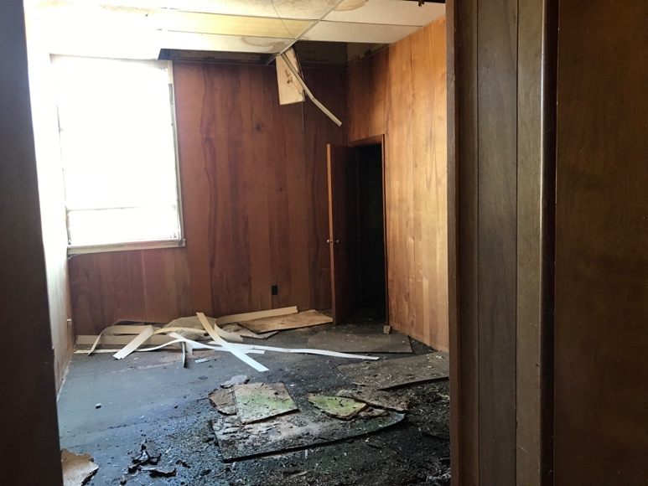

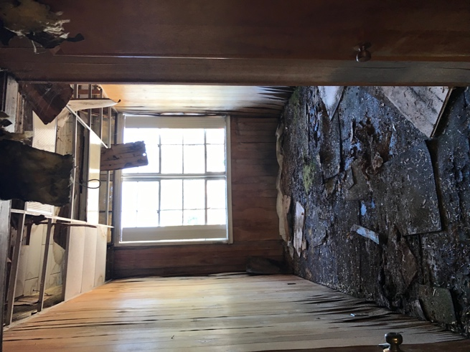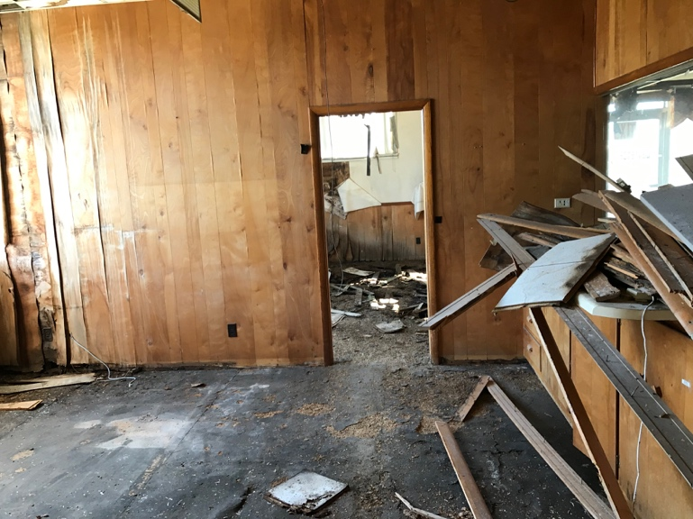

Unchecked water damage over the last decade has severely damaged many of the west side and south end classrooms. City and county officials also have informed the West Gaines School group that the building needs an asbestos assessment. 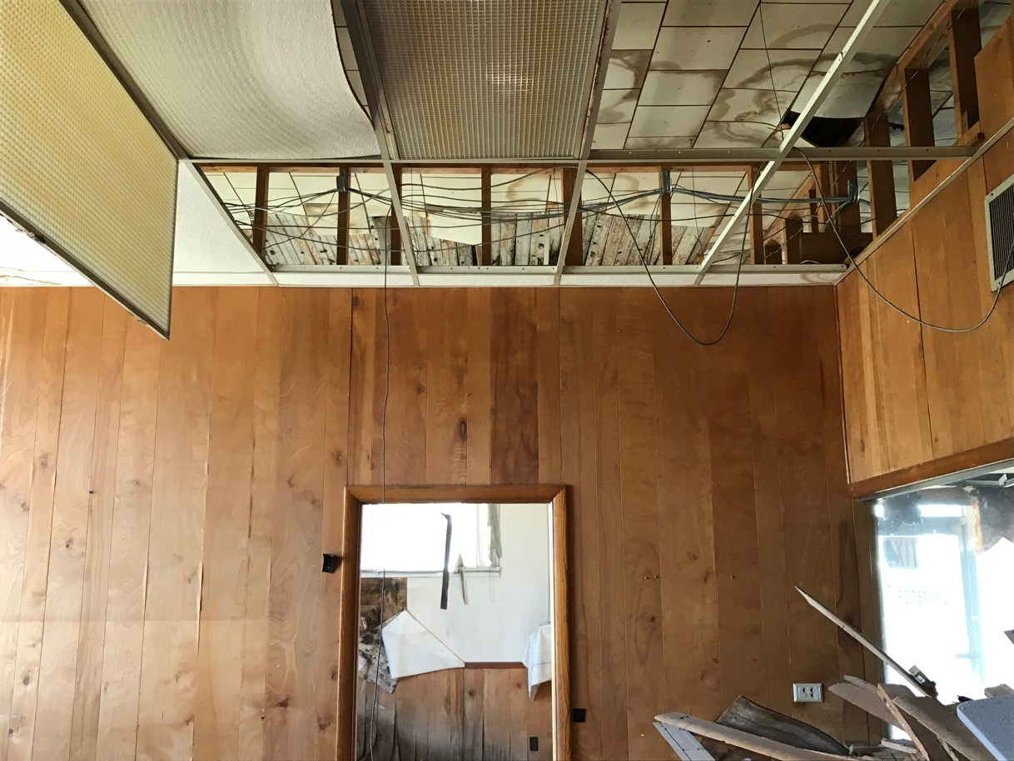
Not all bad news--portion of original school ceiling are extant and restorable.
Preliminary Recommendations:
1. "Mothball the buidling"
- Address holes in the roof immediately. Add tarp on the roof before installing a temporary roof patch. This will mitigate further damage to the interior.
- Asbestos assessment.
- Patch broken windows; assess which window frames need repair or replacement
- Secure and repair all entrances into the building
- Remove foliage around the building
- Plumbing assessment for future handicap accessible restrooms
2. Clear debris so a better assessment of interior can be made
- Remove deteriorated and damaged building materials and carpets
- Sweep out damaged and decaying materials on the floors
- Patch holes in the floors for safety
- Remove partitions where removal will not damage historic materials and floors
3. Take photographs of areas as you clear them of debris
- Helpful for future grants and National Register nominations
4. Prepare preliminary submission for National Register nomination to Tennessee Historical Commission

Bibliography
Alford, Bobby. History of Lawrence County, Tennessee.
Anderson, James D. The Education of Blacks in the South, 1860-1935. Chapel Hill, NC: Univ. of North Carolina Press, 1988.
Ayers, Edward L. The Promise of the New South Life After Reconstruction. Oxford: Oxford University Press, 2007.
Burns, Harliana. "From Sworn Enemies to Nazi Neighbors to Found Family: The Impact of a World War II German POW Camp on a Rural Tennessee Community and the POWs Who Lived There." M.A. Thesis, Middle Tennessee State University, 2021.
Garrett, Martin A., and Zhenhui Xu. “The Efficiency of Sharecropping: Evidence from the Postbellum South.” Southern Economic Journal 69, no. 3 (2003): 578–95. https://doi.org/10.2307/1061695.
Johnson, Charles Spurgeon, Lewis Wade Jones, Buford H. Junker, Eli S. Marks, Preston Valien, Edwin R. Embree, and W. Lloyd Warner. Statistical Atlas of Southern Counties: Listing and Analysis of Socio-Economic Indices of 1104 Southern Counties. The University of North Carolina Press, 1941.
McKenzie, Robert Tracy. “Freedmen and the Soil in the Upper South: The Reorganization of Tennessee Agriculture, 1865-1880.” The Journal of Southern History 59, no. 1 (1993): 63–84. https://doi.org/10.2307/2210348.
Nashville Banner, 1938-1952.
Niedergeses, Kathy. “African American Schools in Lawrence Co., Tennessee.” Lawrence County Archives.
Niedergeses, Kathy. Commissioners of the City of Lawrenceburg: Lawrenceburg Colored School- West Gaines. Lawrence County Archives, 2011.

Charles Spurgeon Johnson et al., Statistical Atlas of Southern Counties: Listing and Analysis of Socio-Economic Indices of 1104 Southern Counties (The University of North Carolina Press, 1941), 211.
James D. Anderson, The Education of Blacks in the South, 1860-1935 (Chapel Hill, NC: Univ. of North Carolina Press, 1988), 150-51.
Ibid
See History of Lawrence County
Harliana Burns. "From Sworn Enemies to Nazi Neighbors to found Family: The Impact of a World War II German POW Camp on a Rural Tennessee Community and the POWs Who Lived there." Order No. 28414463, (Middle Tennessee State University, 2021). https://ezproxy.mtsu.edu/login?url=https://www.proquest.com/dissertations-theses/sworn-enemies-nazi-neighbors-found-family-impact/docview/2519038226/se-2.
ibid
Kathy Niedergeses, “Board of Education Minutes” in Report to Commissioners of the City of Lawrenceburg: Lawrenceburg Colored School- West Gaines (Lawrence County Archives, 2011)
Ibid
Ibid
Ibid
Quote from, April 13, 1931 West Gaines Case Amended Bill , Lawrence County Archives.
Kathy Niedergeses, “African American Schools in Lawrence Co., Tennessee”
Board of Education Minutes, Lawrence County Archives
Niedergeses, “African American Schools in Lawrence Co., Tennessee”
Nashville Banner, April 21, 1939.
Jackson Sun, April 9, 1941.
"Activities of the Colored People," Nashville Banner, June 4, 1943.

